CVUSD Print Center and Print Driver Instructions

We want to use CVUSD Print Center (quick copy) for any bulk orders such as: packets, assessments, and/or large number of duplicating materials. Please plan ahead and order your required copies. Print Center will deliver your copies to our site within 3-5 days.

Townsend Budget Code: 01 – 0000 – 0 – 1110 – 5710 – 330 - 0000

**OPTION 1:** The first part of this hand out is a step-by-step guide if you want to upload your documents directly to the Print Center website. (Note: files must be **PDF, AI, PDS, or GIF files)**

**OPTION 2:** The second part of this hand out will be installing the print center’s driver (aka SurePDF) and you are able to print afile directly from your computer instantly (DOC, Exam view, PDF, etc.).

**OPTION 1 – Uploading Your Own Document**

**STEP 1**: Go to chino.k12.ca.us click “Staff” click “Print Center – CVUSD” to access the portal:

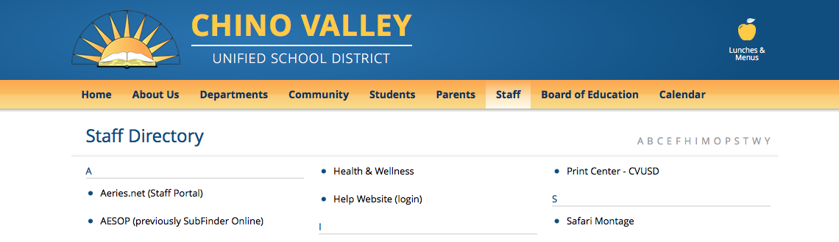

**STEP 2:** Log in

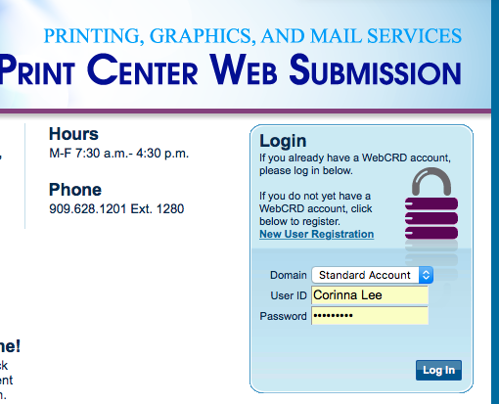

User ID: First name (space) Last name

Password: Same as CVUSD account

**STEP 3:** CVUSD Print Center Home Screen:

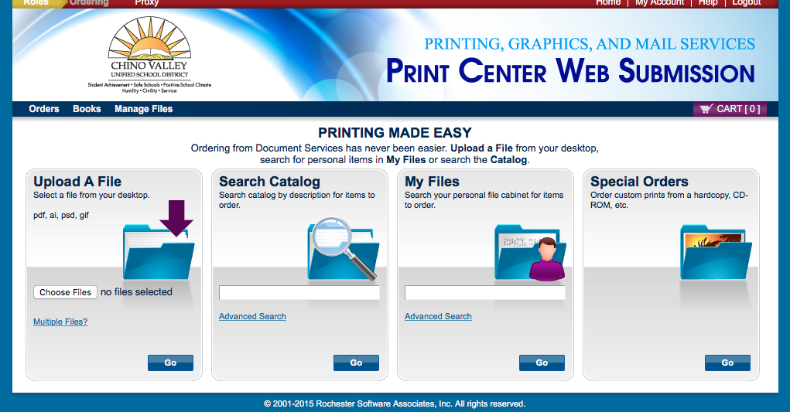

|  |  |
| --- | --- |
| * Upload your file from your computer   + Files MUST be: **PDF, AI, PDS, or GIF** | * Click “Advanced Search” to access Language Arts UPO resources |

**STEP 4:** Once your file is uploaded, you will be prompted to name your order. This will make it easier to reorder your document in the future!

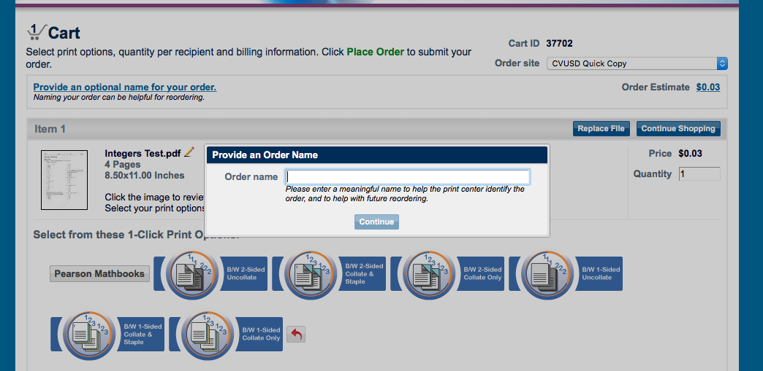

1-Click Print Options

* Collated vs. Uncollated: Enter # of copies you need
* Staple
* 1-Sided vs. 2-Sided

**STEP 5:** Confirm Shipping Information. BE SURE the location you want your package delivered to is listed. To edit your address, click the PENCIL icon. All items that will be sent will be in “Ordered Items”

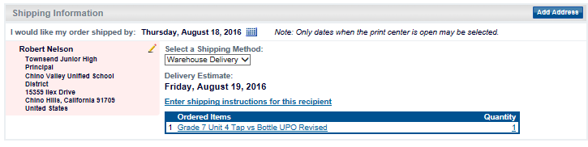

**STEP 6:** Billing Information: Be sure to enter our site’s **Budget Code** (listed below), Select Townsend Junior High from the drop down menu, and hit “PLACE ORDER”

 🟉🟉🟉 **01 – 0000 – 0 – 1110 – 1000 – 5710 – 330 – 0000**

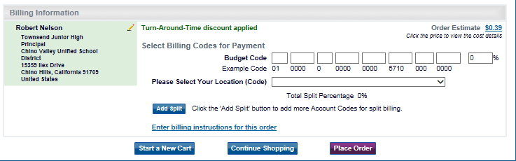

**OPTION 2 – Download Print Center Driver**

**STEP 1:** Navigate to the Print Center login page and find the Sure PDF Driver link. Follow the install instructions from the installer.

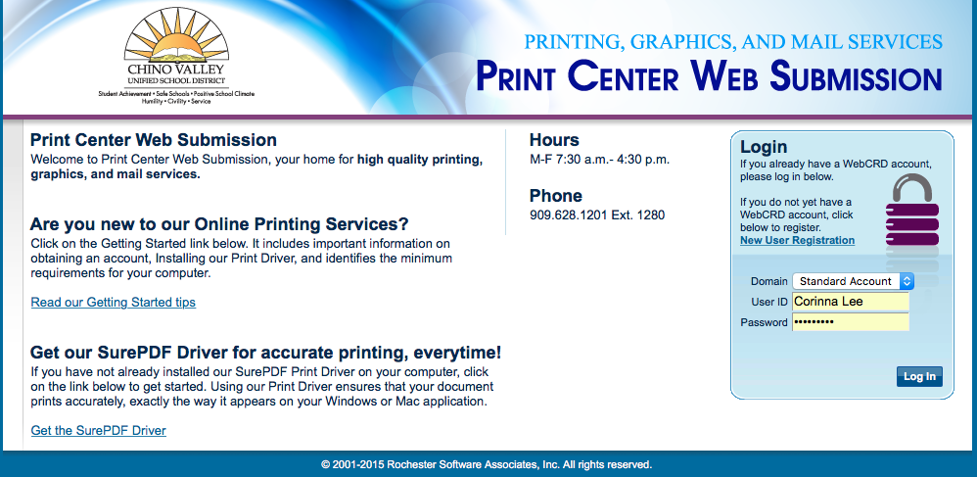

**STEP 2**: Go to the document you wish to send to the CVUSD Print Center. Just like you would normally print your document, hit File ➔ Print and select “CVUSD Print Center”

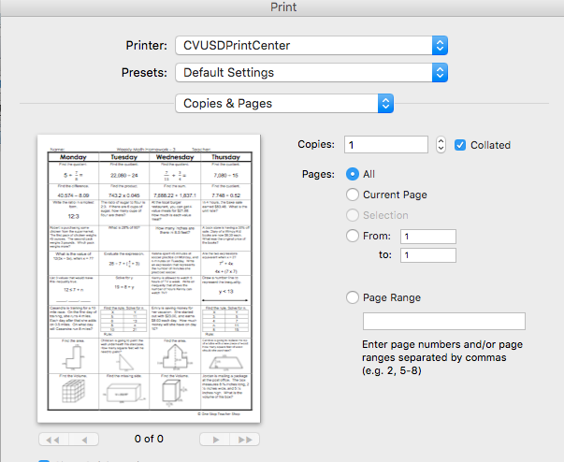If multiple pages, select the range of pages you want to print, otherwise it will print your entire document.

**STEP 3:** Click the “PRINT” or “Ok” button.

* This will launch the CVUSD Print Center website.
* Follow **STEPS 4 – 6 on TOP (naming order, shipping, billing)**